This part is to calculate 24 culm traits as has been showed in the following table

|  |  |  |  |
| --- | --- | --- | --- |
| No. | trait | No. | trait |
| 1 | Max_area_culm | 13 | Max_diameter_culm |
| 2 | Mean_area_culm | 14 | SD_diameter_culm |
| 3 | SD_area_culm | 15 | Major_axis_culm |
| 4 | Max_APR_culm | 16 | Minor_axis_culm |
| 5 | Mean_APR_culm | 17 | Wall_thickness_culm |
| 6 | SD_APR_culm | 18 | MENTA |
| 7 | CHA_culm | 19 | MAXTA |
| 8 | CHR_culm | 20 | SDTA |
| 9 | CCR_culm | 21 | Total_volume_culm |
| 10 | Total_area_culm | 22 | Total_SA_culm |
| 11 | TN | 23 | Culm_density_mean |
| 12 | Mean diameter_culm | 24 | Culm_density_total |

To employ the code for culm traits extraction, the file structure should be like the this:

/Sanple1/

origin/

segmented/

As has been provided in the demo, there are 80 original slices and 80 corresponding segmented slices of one single rice plant, original slices could been found in folder “/Sample1/original”, and segmented slices in folder “/Sample1/segmented”. Both origin slices and segmented slices were renamed regularly, for origin slices, there are “origin (1)”, “origin (2)”, “origin (3)”, …, ”origin (80)”, and for segmented slices, there are “segmented (1)”, “segmented (2)”, “segmented (3)”, …, ” segmented (80)”, make sure that “segmented (i)” is the binary segmented result of “origin (i)”.

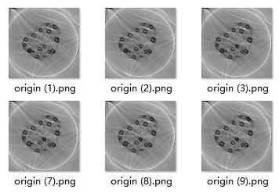 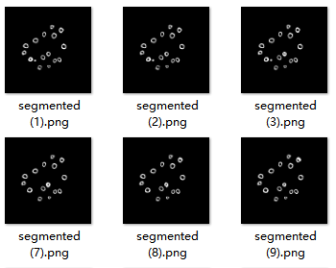

Make sure the variable value of “folder” in line 245 in “main.cpp” has been changed to the absolute path where you put the folder “Sample1”.

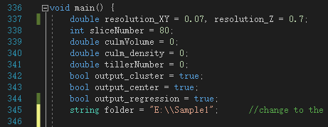

Recommended environment to run the program

Visual studio 2015 (v140)

PCL-1.8

OpenCV 330

Results

Run the code and the console should output like this:

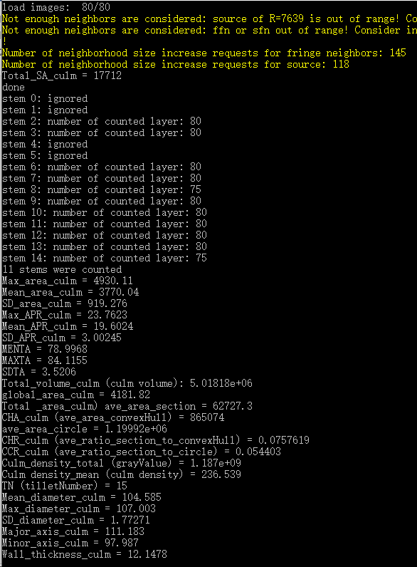

Now, there are several files, “center.txt”, “cluster.txt”, “regression.txt” and “surface.ply” in the folder “/Sample1”, these are generated automatically by the process and you can open these files either with CloudCompare or Meshlab to find out how the code works and check the correctness of the process. If opened with Meshlab, pre-open options should be changed as follows:

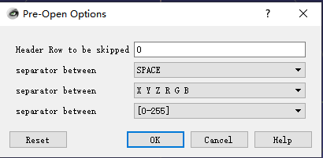

**Separated the culms**

Together there are 80 slices for each rice plant, and they form the 3d image of the rice culm. The sections of culms form several connected components at different location in a segmented slice, the connected components of the sections of a specific culm changes gradually with height. According to graduality, it could be determined that which connected component at the next slice is corresponding to the current one. Thus the 3d image can be separated into several bunches, each bunch is the combination of sections of the same culm but locate at different height.

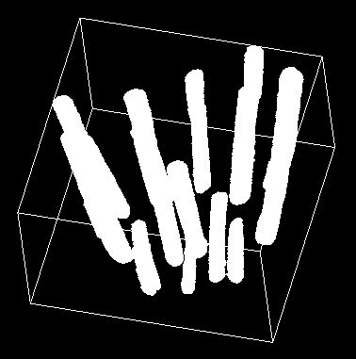 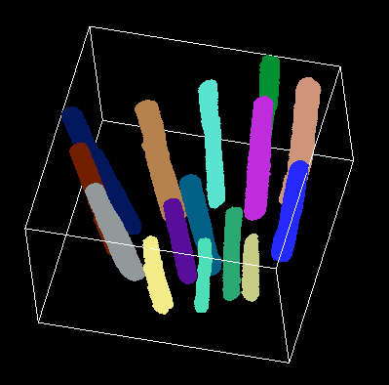

# Cloud points of stems before (left image) and after (right image) clustering,

# “/Sample1/cluster.txt” opened with CloudCompare

**Compute tiller angles**

After all the stems have been separated, for each stem, calculate the gravity center of each layer, determine the tiller angle of the stem according to the regression line of these gravity centers.

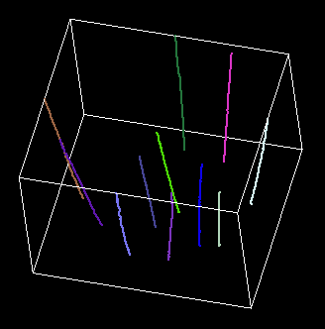 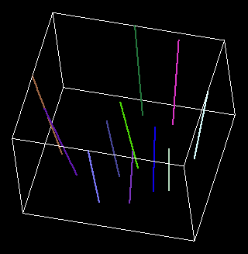

# Gravity center points of each layer for each stem (left image) and regression line of each stem (right image)

# “/Sample/center.txt” and “/Sample/regression.txt” opened with CloudCompare

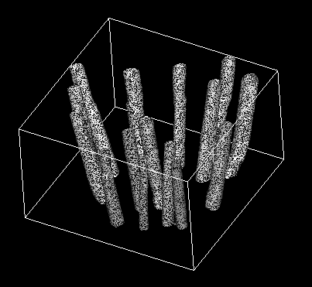

# Delaunay triangulation of external surface of stems

# “/Sample/surface.ply” opened with CloudCompare

Look into “/Sample1/detail_param.txt” for more detail traits of each stem.

